IDEATION PHASE – DOCUMENT 3:

EMPATHY MAP CANVAS
Date | 06 November 2025
Team ID | NM2025TMID08793
Project Name | Lease Management
Maximum Marks | 4 Marks

Title: Empathy Mapping for “Lease Management”

Objective
The goal of this empathy mapping phase is to understand the emotions, motivations, and challenges of every stakeholder involved in the Lease Management system — including tenants, landlords, property managers, and administrative staff.
By mapping what each user Says, Thinks, Does, and Feels, we can design a more human-Centered Lease Management application that solves real problems instead of just storing rental data.

Stakeholders Identified
The empathy map focuses on four key user personas in the Lease Management ecosystem:
Persona | Role | Goal | Pain Points
Tenant | Rents property | Clear, simple rent & lease process | Hidden charges, manual paperwork, delayed updates
Landlord /  Property Owner | Leases property | Get rent on time & track tenants | Rent delays, no proper record system
Property Manager | Handles multiple rental units | Monitor leases, payments, renewals | Manual tracking, reminders, spreadsheets
Admin /  Accountant | Manages bills & compliance | Maintain clean audit and payment logs | Data mismatch, lost documents, no history

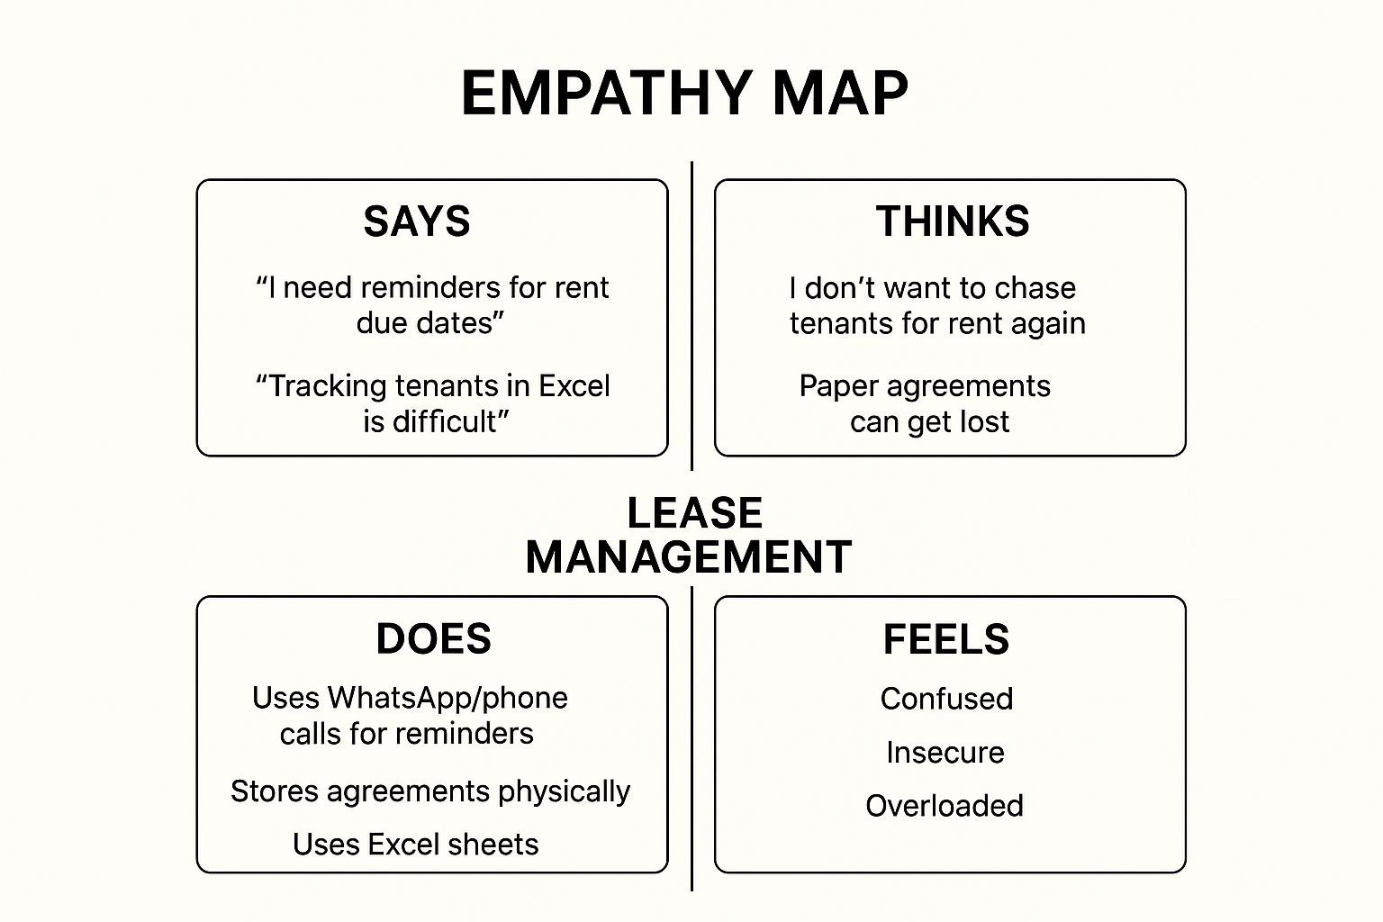

Empathy Map Canvas Layout
Below is the empathy mapping framework applied to all four personas.

Quadrant | Description | Key Insights
SAYS | What users express verbally during interaction or interviews | “I need reminders for rent due dates.” / “Tracking tenants in Excel is difficult.”
THINKS | What users think internally but may not openly share | “I don’t want to chase tenants for rent again.” /  “Paper agreements can get lost.”
DOES | Actions or behaviours users perform | Uses WhatsApp/phone calls for reminders, stores agreements physically, uses Excel sheets
FEELS | Emotional state, frustrations, and aspirations | Tenants feel confused, landlords feel insecure, managers feel overloaded and stressed

Empathy Map Analysis
By mapping these insights, several key observations were made:
- Emotional Connection:
Tenants and landlords both feel anxious due to unclear rent status and lack of transparency.
- Behavioural Pattern:
Most stakeholders still depend on manual processes like paper files, phone reminders, or spreadsheets.
- Cognitive Gap:
Stakeholders know digital solutions exist, but lack automation and centralization.
- Pain Point Highlight:
Admins struggle with rent history, document tracking, renewal reminders, and legal compliance.

Insights Derived
From the empathy mapping exercise, five actionable insights were derived:
- Automation reduces workload.
Users want automatic reminders for rent, expiry, and documents.
- Transparency builds trust.
Rent status, tenant history, and payment logs must be visible.
- Centralization increases efficiency.
One dashboard for all leases, tenants, and payments is needed.
- Digital documentation prevents risk.
Paper contracts can be lost or damaged.
- Alerts = peace of mind.
Notifications reduce manual follow-ups and conflicts.

Design Implications for Lease Management
Insight | Design Decision
Rent delay issues | Add automated rent reminder system
Document tracking problems | Enable digital agreement upload & expiry alert
Manager workload | Create lease dashboard with active, expired, pending leases
Tenant confusion | Provide tenant portal with rent history & bills
Owner transparency need | Auto-generate report showing rent received & pending

Empathy Map Canvas Summary
The empathy map revealed that the success of a Lease Management System depends not only on storing lease data, but on reducing stress, improving clarity, and building trust among all stakeholders.
A well-designed Lease Management solution will:
- Automate reminders & renewals
- Track rent and documents in real time
- Reduce manual effort for managers
- Improve tenant–owner transparency
- Provide audit-ready records for admin

In short, empathy mapping transformed Lease Management from a basic record system into a userdriven, trust-building solution.

